CLDV6211

POE PART 1

ST10443730

Table of contents:

Screenshots of work …………………………………………………..…… pg 3

Theory questions ……………………………………………………..…….. pg 5

References …………………………………………………………..……….. pg 8

Web App link:

<https://st10443730.azurewebsites.net/>

GitHub repository:

<https://github.com/IIEWFL/cldv6211-part-1-ST10443730.git>

Screenshotted pictures:

Query Editor:

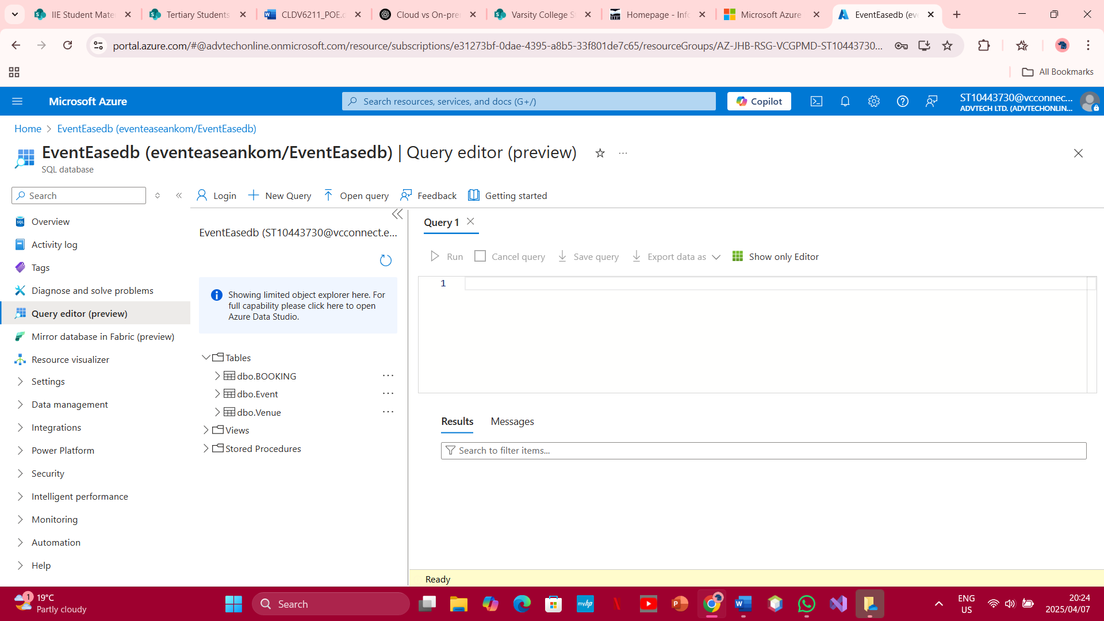

Resources page:

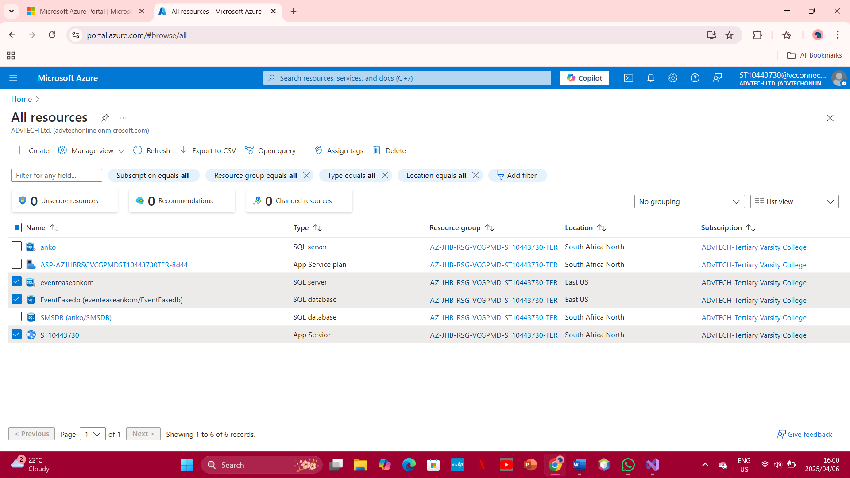

Publishing from visual studios:

Cloud Computing Basics:

1. Security:

On-premise security is the sole responsibility of the company that is making use of the security measures. This gives them complete control and authority over the size, features, components and accessibility of the database and its data.

With Cloud Security on the other hand, the software is managed and run by the selected service provider’s servers and the company’s applications are not hosted onsite like with on-premise. The third party vendor has access to the data and regulates their encryption keys.

Deployment Speed:

On-premise deployment is a lot slower due to hardware procurement, setup and configuration. This means that a lot has to be prepared before the deployment process can take place, the entire process can take weeks.

Cloud, on the other hand, has a much faster deployment rate due to the fact that there is no need to procure any hardware or to set said hardware up as everything is on the cloud, this cuts down the time needed for the resources to be deployed from weeks to mere minutes. This is as a result of the resources being provisioned instantly.

Resource Management:

On-premise resource management is a lot more difficult to scale than cloud based due to it being limited to physical hardware. This makes quick scaling difficult and it can often be more expensive upfront.

With Cloud however, there is what we call auto scaling which is where the database scales up and down automatically as the needs of the company making use of its’ changes needed. With cloud, you only pay for what you need.

1. SaaS vs. PaaS vs. IaaS

SaaS:

The application is hosted on a remote server and can be accessed via the internet. The user isn’t responsible for the updating of any hardware or software. All management is doe by the host of the fortware, all the end user does is make use of the platform.

PaaS:

Unlike SaaS which is only accessible via the internet, PaaS provide a software creation platform over the internet which gives developers the freedom to focus on building the software without having to stress about operating systems, storage, software updates or any of the infrastructure. It also allows businesses to design and create their applications themselves as well as integrate special software components into the application.

IaaS:

Unlike its two other counterparts, clients are responsible for managing the different aspects which include applications, runtime, middleware, data and operating systems. This gives the client complete control over their infrastructure and makes it the most dynamic of the three.

PaaS for Event Ease:

Features can be built and deployed more quickly, the staff at event ease won’t have to worry about maintaining or taking care of the application/database themselves as this is done for them. PaaS is also scalable and will grow with the needs of the business as they arise/increase. An example can be the use of Firebase which can handle sudden user growth without any downtime.

References

1. OpenAI, 2025. *ChatGPT conversation*. [online] Available at: <https://chatgpt.com/c/67f363e1-248c-8003-b281-e8dc654cca97> [Accessed 5 April 2025].
2. SentinelOne, 2024. *Cloud vs. On-Premise Security: What’s the Difference?*. [online] SentinelOne. Available at: <https://www.sentinelone.com/cybersecurity-101/cloud-security/cloud-vs-on-premise-security/> [Accessed 6 April 2025].
3. BMC Software, 2023. *SaaS vs PaaS vs IaaS: What’s the Difference and How to Choose*. [online] BMC Blogs. Available at: <https://www.bmc.com/blogs/saas-vs-paas-vs-iaas-whats-the-difference-and-how-to-choose/> [Accessed 6 April 2025].